KARNATAKA VETERINARY, ANIMAL & FISHERIES SCIENCES UNIVERSITY*,*

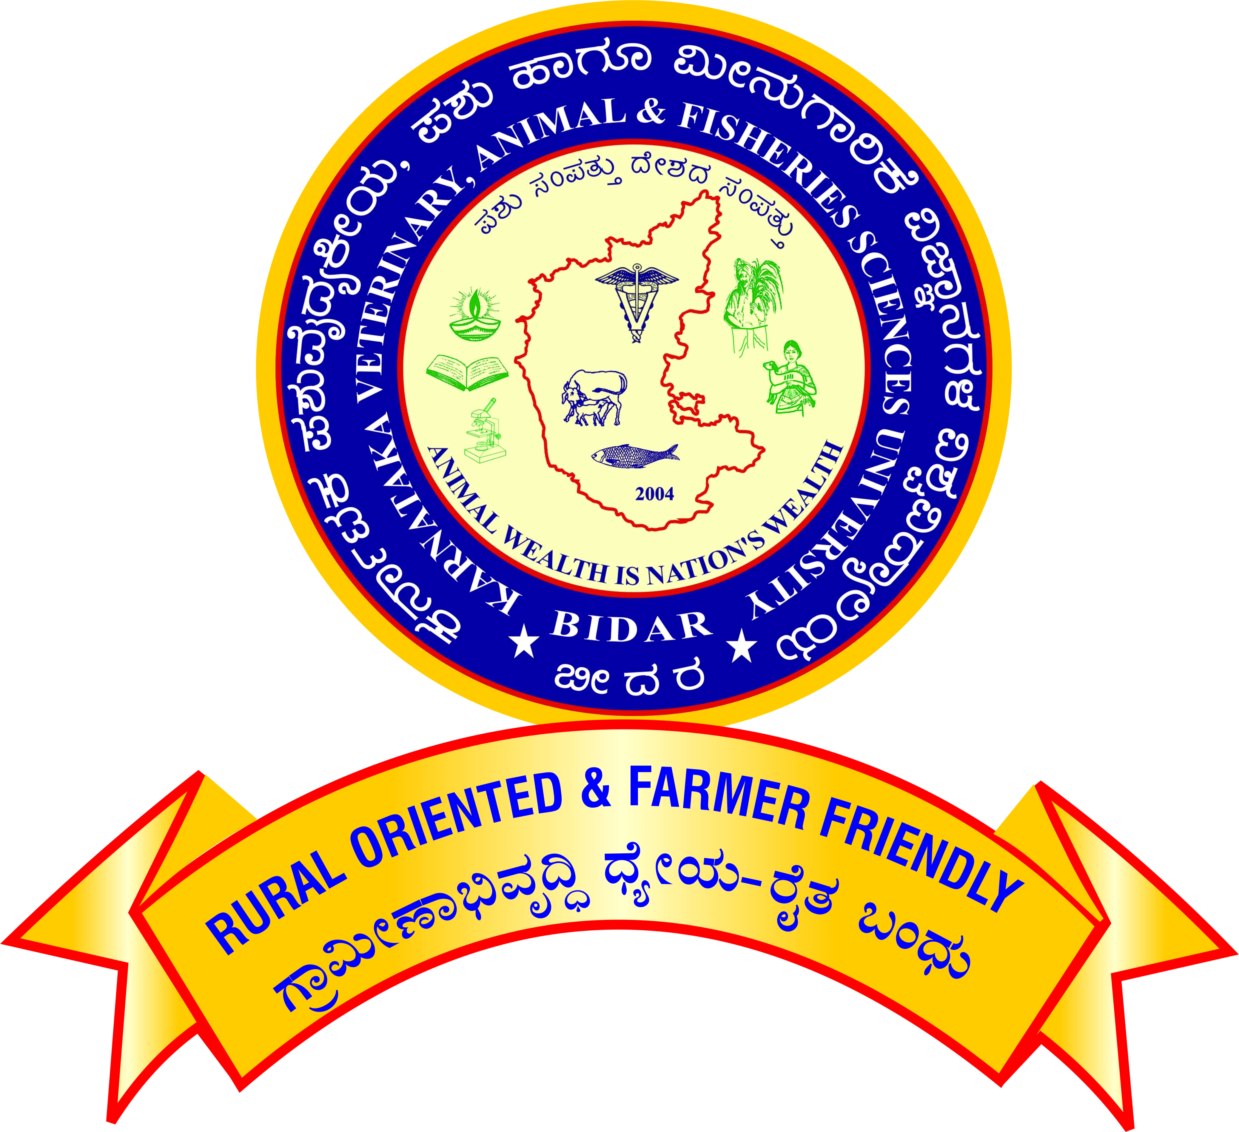Nandi Nagar, PB No.6, BIDAR-585401, (Karnataka

**Office of the Registrar**

**Phone :** 08482-245241/245360

www.kvafsu.edu.in

**PROFORMA TO APPLY FOR PROMOTION UNDER CAREER ADVANCEMENT SCHEME - 2016**

**ASSISTANT PROFESSOR OF PHYSICAL EDUCATION**

**(**Academic Level 11 **TO** Academic Level 12)

**[From Pay Band ₹ 68,900 to 2,05,500 TO Pay Band ₹ 79,800 to 2,11,500]**

|  |  |  |  |  |  |  |  |  |  |  |  |  |  |  |
| --- | --- | --- | --- | --- | --- | --- | --- | --- | --- | --- | --- | --- | --- | --- |
| **1** | | Name | | | | | |  | | | | | **Affix recent passport size photograph** | |
| **2** | | Designation and full address | | | | | |  | | | | |
| **3** | | Name of the Department / Section / Unit / Scheme | | | | | |  | | | | |
| **4** | | Date of birth  **(SSLC Marks Card – Mandatory)** | | | | | |  | | | | | | |
| **5** | | Academic qualification | | | | | |  | | | | | | |
| Examination / Degree | | | | | | | Year | | Subject | | University | Class / Division  / OGPA / CGPA | | |
|  | | | | | | |  | |  | |  |  | | |
|  | | | | | | |  | |  | |  |  | | |
|  | | | | | | |  | |  | |  |  | | |
| **6** | | Date of joining to duty at KVAFSU, Bidar as Assistant. Professor of Physical education in the (Academic Level-10/AGP 6000)  **(Enclose copies of the appointment order & duty report)** | | | | | | | |  | | | | |
| **7** | | Date on which the pay band of ₹68,900 – 2,05,500 (Academic Level -11) was attained  **(Enclose copies of the promotion order& duty report)** | | | | | | | |  | | | | |
| **8** | | Date of completion of 5 years of service in the cadre of Asst. Prof. of Phy.Edu. in the pay band of ₹68,900 – 2,05,500 (Academic Level -11) | | | | | | | |  | | | | |
|  | | | | | | | | | | | | | | |
| **9** | | **Performance/contribution of corporate Work during the assessment period**  (Activities to be certified by competent authority) | | | | | | | | | | | | |
| a) | | | Organizing various inter campus/inter University Tournaments | | | | | | | | | |
| b) | | | Serving as a team Manager/ Coach of the college Sports/Cultural teams in the Inter Campus/Local Tournaments | | | | | | | | | |
| c) | | | Accompanying the University Sports/ Cultural team as a Manager/Coach | | | | | | | | | |
| d) | | | Attending as-sports team selection committee member (State/ University/ District/Taluk Teams ) | | | | | | | | | |
| e) | | | Serving as Sports and Cultural Council Member of the University | | | | | | | | | |
| f) | | | Serving as Technical Official/Experts outside the University | | | | | | | | | |
| g) | | | Attending as Committee Member of Field Day/ Krishimela/ Convocation/ National Festival/ HSC /Disciplinary Committee or any Other activities assigned by the College/University. | | | | | | | | | |
| h) | | | Other works attended by Physical Education Teacher | | | | | | | | | |
| i) | Developing Sports Infrastructure like outdoor Games/ Gymnasium and indoor games. | | | | | | | | |
| ii) | Conducting sports activities in connection with the College day, Hostel day and during any other occasions. | | | | | | | | |
| **10** | | **Published work during the assessment period** | | | | | | | | | | | | |
| a) | | | For each full length article published in refereed journal | | | | | | | | | |
| b) | | | For each book published/ edited | | | | | | | | | |
| i) | | Recognized publishers with ISBN | | | | | | | |
| ii) | | Chapters in standard books with ISBN | | | | | | | |
| iii) | | Published individually | | | | | | | |
| iv) | | Research/Extension Bulletin | | | | | | | |
| c) | | | i) | | For each research note/communication in a journal | | | | | | | |
| ii) | | Abstract in symposium/ seminar/ workshop/ training manual/proceedings of the workshop | | | | | | | |
| iii) | | Popular article/leaflet | | | | | | | |
| d) | | | Any other publications::– | | | | | | | | | |
| a) | | As Author/Compiler of POP/Editor | | | | | | | |
| b) | | As Assoc. Editor/ Asst. Editor/Publisher/Compiler of other publications | | | | | | | |
|  | | | | | | | | | | | | | | |
| **11** | | | **Summer Schools/Winter Schools/Refresher Course/Special Training/ Symposia/ Seminar/ Workshop/Conference/Coaching Camps** | | | | | | | | | | | |
| a) | | | For Organizing each activity as in the title  (i) Upto10 days  (ii0 More than10 days | | | | | | | | |
| b) | | | For participation in Summer School/Winter School/Refresher Course/  Orientation Course of **10 days duration** | | | | | | | | |
| c) | | | For participation in a course/ programme from amongst the categories of Refresher course/ Research methodology course workshops/syllabus up gradation workshop/ Teaching- Learning Evaluation/ Technology Programmes/ Faculty Development Programme of at least ten days duration (or completed two course of at least five days duration in lieu of one MOOCs course in the relevant subject (with e-certification), or contribution towards the development of 10 modules of MOOCs course/ contribution towards conduct of a MOOCs course during the assessment period; and | | | | | | | | |
| d) | | | For participation in Special Training/ Orientation Programmes/ Symposia/ Seminars/ Conferences/ Workshops etc.(except Annual workshop) | | | | | | | | |
| e) | | | University Coaching camp for AIU /ICAR events/year/event | | | | | | | | |
|  | | | | | | | | | | | | | | |
| **12** | | | | **International Exposure**  International official Visits/ Training/ Courses (outside India only) | | | | | | | | | | |
|  | | | | | | | | | | | | | | |
| **13** | | | | **Awards/ Distinctions received** | | | | | | | | | | |
| a) | | International award | | | | | | | | |
| b) | | National award | | | | | | | | |
| c) | | State award | | | | | | | | |
| d) | | University award | | | | | | | | |
| e) | | Professional Society Award | | | | | | | | |
|  | | | | | | | | | | | | | | |
| **14** | | | | **Corporate / other activities** | | | | | | | | | | |
|  | | | | a) | | Activities performed as External Examination Coordinator–Associate Coordinator/ Chief Warden/ Wardens/ Staff Advisor/Tour Leader and Co- Tour leader (State/ All India) /NSS Programme Officer–NSS /Indian Red Cross Society Programme Officer/ Coordinator /NCC Officer /Farm Management /Academic, General, Financial Management (as AO/ DAO/ AAO/Dy. R/ AR/ DC/ AC /Dy. Librarian /Asst. Librarian etc.)/ Scrutinizing UG/PG grades P.G. Co-ordinator/ Seminar In charge Leader/ Member in monitoring team. | | | | | | | | |
|  | | | | b)  c) | | Activities performed as Member- Co-chairman–Chairman of different committees of National–International–activities/RAWE–Assoc. Coordinator– participation in RAWE camp/ Internship/ Tournament Organized/ Spl. Officer of SC-ST Cell/ Minority Cell/Technical Assistant (Part-time)/ Students Counselor/ Leader for exposure visit of Farmers/ Liaison Officer for BOM/VIP’s tours assigned by the University/ Participation in Melas /Exhibitions as State, National, International levels representing University/Member/Co-Chairman in different committees of UAS activities/Team Manager and Co-Team Manager to Sports/ Cultural Activities/Stock verifying Officer/Antiragging squad member/ grade point conversion work/worked as Rapporteur/Co-Chairman in the National/ International Conferences, Seminars, Workshops/Symposium etc., Member of Class and Exam time-table committee, Press meet work/participation in UG&PG admission/ member involve in organization, selection of farmers/ Teachers for nomination to various awards.  **Any other activities duly certified by the controlling officer/ University** | | | | | | | | |
|  | | | | | | | | | | | | | | |
| **15** | | | | **Outstation Service** | | | | | | | | | | |
|  | | | | | | | | | | | | | | |
| **16** | | | | **Any other significant achievement (with documentary proof)** | | | | | | | | | | |

## Signature of the Asst. Professor of Physical Education

Verified that the information furnished by the Scientist / Teachers is correct.

|  |  |
| --- | --- |
| **Signature of the**  **Head of the Department /** | **Signature of the**  **Controlling Officer** |